EASO meets with Spanish authorities to discuss asylum situation in the country

* 25TH JANUARY 2019

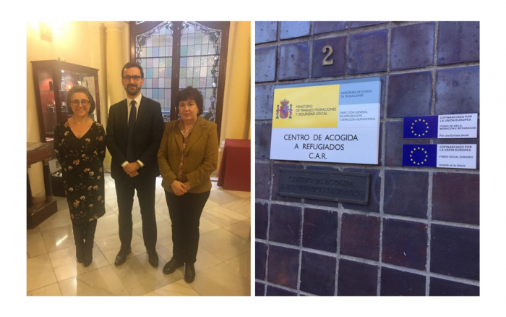

***The European Asylum Support Office (EASO) has reaffirmed its full commitment to support for Spain if so requested.***

The Executive Director a.i. of the European Asylum Support Office (EASO), Mr. Jamil Addou, has held meetings with Spanish authorities during a working visit in Madrid. During the meetings with the Ministry of the Interior, responsible for the asylum procedure, and the Ministry of Labour, Migrations & Social Security, responsible for the reception of asylum seekers, Mr. Addou discussed the actions taken by the Spanish authorities to manage the increase in arrivals of migrants in recent months, as well as the associated increase in asylum applications.  
  
Referring to the commitment of EU support for Spain made by Commissioner Dimitris Avramopoulos last August, Mr. Addou stated that Spanish national authorities can count on an intensified level of support from EASO should it be needed.   
  
During the working visit to Madrid, Mr. Addou also met with officials from UNHCR in Madrid and other stakeholders, including several NGOs. He also visited a reception center for asylum seekers.